

MSc Data Science Project
7PAM2002
Department of Physics, Astronomy and Mathematics

Data Science FINAL PROJECT REPORT

Project Title:
Smart Building IoT: Detecting Room Occupancy Using Environmental Sensors.
Student Name and SRN:
Anu Bhukya
24004718

Supervisor: Carolyn Devereux
Date Submitted: 17.04.2026
Word Count: 4976

DECLARATION STATEMENT

This report is submitted in partial fulfilment of the requirement for the degree of Master of Science in Data Science at the University of Hertfordshire.
I have read the detailed guidance to students on academic integrity, misconduct and plagiarism information at Assessment Offences and Academic Misconduct and understand the University process of dealing with suspected cases of academic misconduct and the possible penalties, which could include failing the project or course.
I certify that the work submitted is my own and that any material derived or quoted from published or unpublished work of other persons has been duly acknowledged. (Ref. UPR AS/C/6.1, section 7 and UPR AS/C/5, section 3.6)
I did not use human participants in my MSc Project.

I hereby give permission for the report to be made available on module websites provided the source is acknowledged.

Student Name printed: Anu Bhukya

Student Name signature: Anu

Student SRN number: 24004718

SCHOOL OF PHYSICS, ENGINEERING AND COMPUTER SCIENCE

Abstract
Currently buildings require systems which enable them to detect when people are present because that capability has become essential for sustainable urban environments. My study develops a machine learning system which uses high-precision methods to determine room occupancy in smart buildings. I developed and refined three machine learning models which included Gradient Boosting Random Forest and SVM using the Occupancy Detection dataset. My research shows that the optimized Gradient Boosting model achieved a near-perfect accuracy of 0.9957 and an F1-score of 0.9899. Through SHAP-based explainable AI, I proved that light intensity and CO₂ levels are the primary drivers of occupancy detection. This study confirms that my predictive system provides the robust, data-driven foundation necessary for automating HVAC and lighting controls to maximize institutional energy savings.
Contents
Abstract 1
Chapter 1: Introduction 1
Introduction 1
Background of the Study 1
Current Practice 1
Problem Statement 1
Aim and Objectives of the Study 2
Research Questions 2
Structure of Report 2
Chapter 2: Background 3
Overview 3
Literature Review 3
Research Gap Identified 4
Chapter 3: Dataset 5
Overview 5
Description of the Dataset 5
Features of the Dataset 5
Justification of Dataset Selection 5
Data Cleaning 6
Index Column Removal 6
Date Conversion 6
Feature Removal 6
Missing Values Handling 6
Exploratory Data Analysis 6
Chapter 4: Ethical Consideration 10
Personal Data and Privacy 10
GDPR Considerations 10
Ethical Approval 10
Permission and Licensing 10
Chapter 5: Methodology 11
Overview and Tools Used 11
Feature Engineering and Dataset Preparation 11
Model Selection and Technical Rationale 11
Hyperparameter Optimization 12
Model Evaluation 12
K-Fold Cross Validation 13
Sensor Dominance and Failure Analysis 13
Temporal Generalization Analysis 14
Explainable AI (XAI) 14
Chapter 6: Results 15
Overview 15
Initial Model Performance 15
Optimized Model Performance 15
Cross Validation Results 16
Feature Importance Analysis (Model Success vs Failure) 17
Temporal Generalization Analysis 18
Explainable AI Results 18
Research Questions Addressed and Practical Applicability 20
Chapter 7: Analysis and Discussion 21
Overview of Results 21
Best Performing Model 21
Comparison with Previous Research 21
Sensor Importance and Research Question Analysis 21
Practical Applicability of the Model 22
Limitations of the Study 22
Relationship to Research Objectives 22
Chapter 8: Conclusion 23

Chapter 1: Introduction

Introduction
Smart buildings use Internet of Things (IoT) technologies to improve energy efficiency, comfort, and resource management. Buildings use environmental sensors to detect room occupancy which includes temperature and humidity and light and CO₂ sensors. This system controls lighting and HVAC systems to decrease energy usage while enhancing building performance(Khan et al., 2024).

Background of the Study
Buildings consume a significant portion of global energy, much of which is wasted due to inefficient management of lighting, heating, and ventilation systems. IoT-based sensing technologies enable buildings to monitor indoor environmental conditions and infer occupant presence through data collected from sensors such as temperature, humidity, light intensity, and carbon dioxide levels. By analyzing these environmental indicators using machine learning techniques, occupancy patterns can be predicted accurately. The systems decrease energy consumption while they enhance indoor comfort and they enable smart building control methods (Khan et al., 2024; Mena-Martinez et al., 2024)

Current Practice
Modern smart building systems use IoT sensors such as Passive Infrared (PIR), CO₂ sensors, and environmental monitoring devices to detect room occupancy. The systems use real-time sensor data together with building management systems to automatically control lighting and heating and workspace usage which results in better energy performance and higher employee productivity(Blazevic et al., 2024)

Problem Statement
Current IoT-based smart building technologies face difficulties in achieving correct room occupancy identification because of their existing technological limitations. Multiple current systems depend on one sensor type because their measurements can fail when environmental factors change or sensors stop working. The system identification process suffers from two issues because identifiable data and environmental changes that happen throughout the day create difficulties in establishing accurate predictions. The development of strong machine learning systems requires the ability to process multiple environmental sensor data while maintaining performance during sensor failures and environmental changes (Khan et al., 2024; Mena-Martinez et al., 2024)

Aim and Objectives of the Study

Aim
The project will create an IoT-based machine learning system which uses environmental sensor information to determine room occupancy with high precision.

Objectives
- To gather and assess environmental sensor information which includes light intensity, temperature, humidity, and CO₂ levels.
- To create machine learning systems that will forecast room occupancy patterns.
- To investigate how sensor malfunctions affect system performance for modeling purposes.
- To evaluate model comprehensibility through Explainable AI methods which include SHAP.
- To assess model strength by using data obtained during various times throughout the day.

Research Questions
- RQ1. Is light intensity the dominant predictor, and can the model function effectively if that sensor fails?
- RQ2. How does the model's accuracy change when testing on data from a different time of day than the training set?
- RQ3. Can Explainable AI (e.g., SHAP dependence plots) reveal the non-linear relationship between CO₂ levels and the probability of room occupancy?

Structure of Report
The report contains multiple chapters which define its organizational structure. Chapter 1 introduces the research topic and objectives. The second chapter presents a literature review about smart building Internet of Things technology and occupancy detection systems. The third chapter presents information about the dataset and sensors which were utilized in the study. The fourth chapter addresses ethical issues which must be considered. The fifth chapter presents the research method and then the results and discussion and conclusion with references follow.

Chapter 2: Background

Overview
The chapter commences with a summary of existing research studies which examine how Internet of Things (IoT) systems and environmental sensors work together to identify room occupancy patterns in smart buildings. The chapter examines how building occupancy detection systems function to enhance energy conservation and building management operations while describing the various indoor environment monitoring sensors and the machine learning and deep learning methods used to forecast occupancy. The chapter presents current research findings on occupancy detection systems while showing research gaps which led to the need for this study.

Literature Review

Smart Buildings and IoT-Based Occupancy Detection
Smart buildings use Internet of Things technologies to track indoor environmental conditions while they control their operational systems which include lighting and ventilation and heating functions. The automated systems depend on occupancy detection which permits them to establish the current status of room occupancy because it enables them to find out whether rooms have people inside or are unoccupied. Building systems achieve energy efficiency by using precise detection methods which enable them to create comfortable indoor environments. The IoT-enabled systems use sensors to gather environmental data which they analyze through intelligent algorithms to estimate the current number of people present inside a building (Zeleny et al., 2024)

Environmental Sensors for Occupancy Detection
Environmental sensors serve as the primary method for occupancy detection in smart buildings because they provide an affordable and non-invasive solution. The system relies on temperature sensors and humidity sensors and carbon dioxide (CO₂) sensors and light intensity sensors as its primary detection equipment. The presence of people in a space leads to environmental changes which result in higher CO₂ emissions and shifts in temperature and humidity levels. The occupancy status of a room can be determined through machine learning models which track changes in environmental conditions. Environmental sensors provide better protection of personal privacy according to research which compares these systems with camera-based monitoring systems (Kim et al., 2023)

Machine Learning Approaches for Occupancy Detection
Machine learning techniques enable researchers to study environmental sensor data for the purpose of determining whether rooms are occupied. The algorithms used in occupancy detection studies include Logistic Regression and Decision Trees and Random Forest and Support Vector Machines and K-Nearest Neighbors and Gradient Boosting. The algorithms identify specific patterns within environmental data which show when people are present in a space. Ensemble learning methods show strong performance in occupancy detection studies because Random Forest and Decision Tree models maintain their effectiveness when partial sensor data is unavailable(Afolabi et al., 2025)

Indoor Occupancy Detection
The researchers (Mohammadabadi et al., 2022)developed a CNN-XGBoost deep learning model which uses environmental sensor data for indoor occupancy prediction. The research utilized CO₂ and temperature and humidity data which researchers obtained throughout a 13-day period from a residential building in Copenhagen. The hybrid system employs convolutional neural networks to extract features which the system uses to perform classification through XGBoost. The system's effectiveness was assessed through a comparison with multiple machine learning and neural network systems which used MAE and confusion matrix and F1 score as evaluation metrics. The results demonstrated that the CNN-XGBoost model achieved the highest accuracy because it used affordable environmental sensors to accurately track occupancy while protecting user privacy.

Research Gap Identified
IoT-based occupancy detection has achieved important advancements however there are still remaining obstacles to overcome. Existing research depends on specific sensors like CO₂ and motion sensors which have limitations because they can fail or provide incorrect measurements under some conditions. The models show their worst performance when they face data from different time periods and environmental test situations. Research about how occupancy detection models respond to sensor failures and environmental changes remains limited. `s need to develop machine learning models which provide clear explanations about how environmental factors affect occupancy prediction results.

Chapter 3: Dataset

Overview
The study utilizes the Occupancy Detection dataset from the UCI Machine Learning Repository. The dataset contains environmental sensor measurements collected from an office room to determine whether the room is occupied or not. The recorded variables include temperature, humidity, light intensity, and carbon dioxide (CO₂) levels. The researchers collected the measurements throughout the study period while they used time-stamped photographs to establish the occupancy status. The dataset contains 20,560 observations and is commonly used for machine learning research on smart building occupancy detection.

Description of the Dataset
The Occupancy Detection dataset was developed to study room occupancy prediction using environmental sensor data. The data were collected from sensors that operated within an office space to track indoor environmental conditions. The dataset includes measurements of temperature and humidity and light and CO₂ concentration which show variations in room presence.
The dataset contains humidity ratio as an additional variable which scientists calculated through temperature and humidity measurements. The occupancy label functions as the final variable which shows whether the room is occupied with (1) or not occupied (0) status.

Features of the Dataset
Table 3.1 shows the features of dataset
Table 3.1: Features of the Occupancy Detection Dataset
No | Feature | Description
1 | ID | Unique identifier for each record
2 | Date | Time when the measurement was recorded
3 | Temperature | Room temperature (°C)
4 | Humidity | Relative humidity (%)
5 | Light | Light intensity (Lux)
6 | CO₂ | Carbon dioxide concentration (ppm)
7 | Humidity Ratio | Derived value from temperature and humidity
8 | Occupancy | Target variable (0 = Not Occupied, 1 = Occupied)

Justification of Dataset Selection
The Occupancy Detection dataset exists as a selection because of its actual environmental sensor data, which proves effective for predicting occupancy in smart buildings. The dataset contains various environmental parameters, which IoT monitoring systems commonly use, including temperature, humidity, light, and CO₂ levels.
The dataset contains labeled occupancy data, which enables researchers to develop and assess machine learning models. The dataset serves as a valid research tool for studying occupancy detection systems because it is easily accessible and widely used in academic studies.

Data Cleaning

Index Column Removal
The index column which includes Unnamed: 0 and numeric index was deleted because it did not help with occupancy prediction.

Date Conversion
The date column was converted into datetime format to ensure proper handling of time-related data.

Feature Removal
The dataset excluded Humidity Ratio feature because it was unnecessary for the analysis.

Missing Values Handling
The dataset was checked for missing values, and rows containing missing data were removed to maintain data quality.

Exploratory Data Analysis
Exploratory Data Analysis EDA enables me to study dataset distributions before they implement machine learning methods. The system tests data quality through its examination of feature distributions and variable relationship analysis and its ability to detect anomalies which helps select essential features.

Occupancy Distribution
The Figure 3.1 shows class imbalance. Around 6400 records represent empty rooms, while about 1700 records represent occupied rooms.
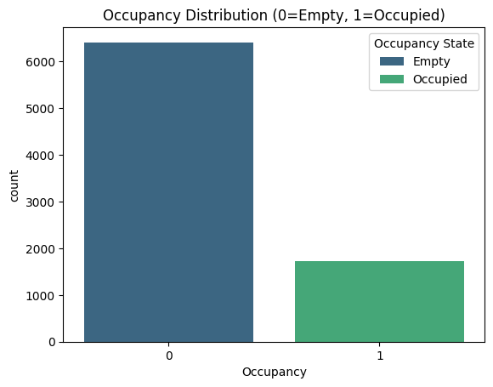
Figure 3.1: Distribution of occupancy classes in the dataset.

Feature Correlation Heatmap
Light shows strong correlation (Figure 3.2) with occupancy at 0.91. CO₂ shows 0.71 correlation. Temperature shows moderate relationship around 0.54.

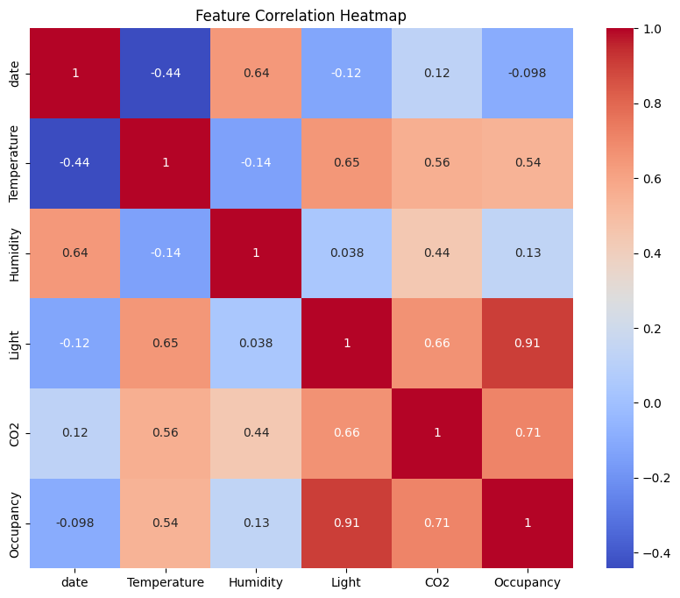
Figure 3.2: Correlation matrix showing relationships among environmental sensor features.

Boxplots of Environmental Features by Occupancy
Occupied rooms show higher CO₂ levels near 900 to 2000 ppm and higher light levels near 400 to 500 lux as per Figure 3.3.
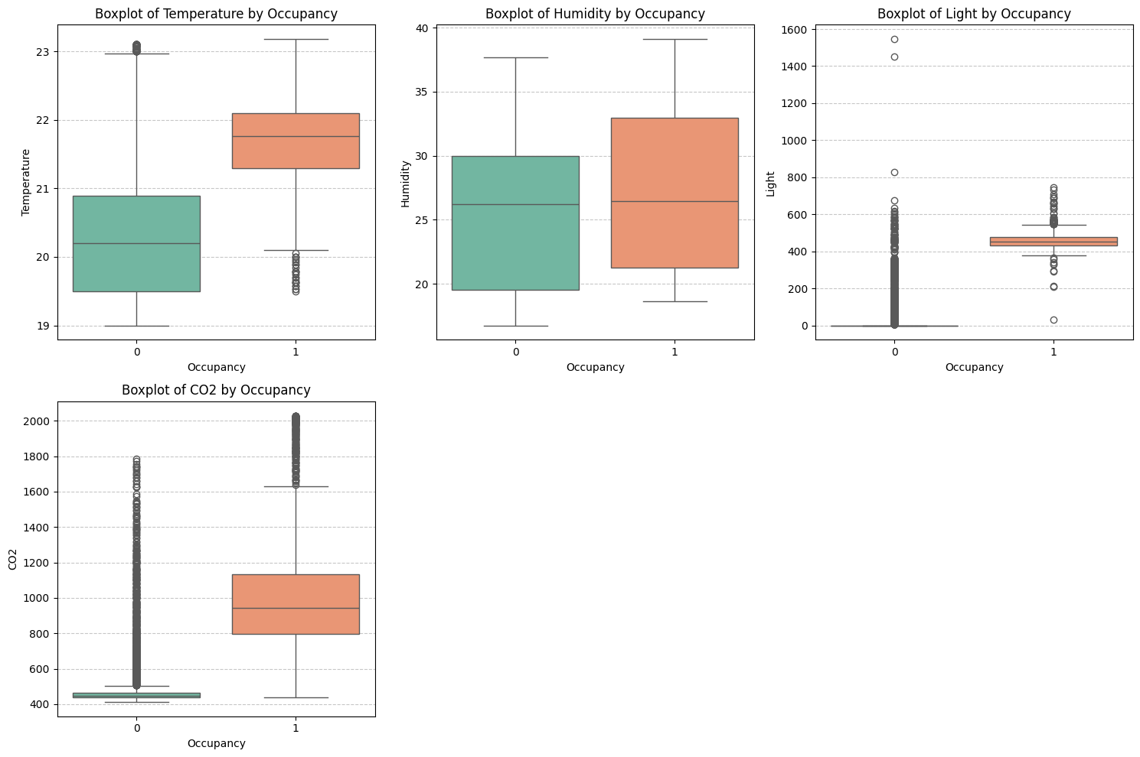
Figure 3.3: Boxplot comparison of environmental features

Scatter Plot of Light vs CO₂
Figure 3.4 shows occupied rooms cluster around light levels between 400 and 600 lux with CO₂ from 700 to 2000 ppm.
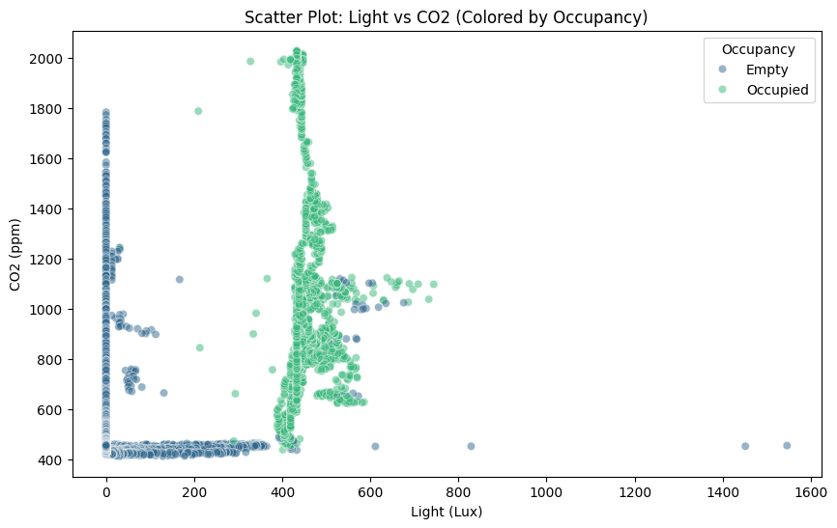
Figure 3.4: Scatter plot showing relationship between light intensity and CO₂ levels.

Pairwise Scatter Plots of Environmental Sensors
Pairwise plots in Figure 3.5 show separation. Occupied rooms show higher light near 450 lux and higher CO₂ near 900 ppm.
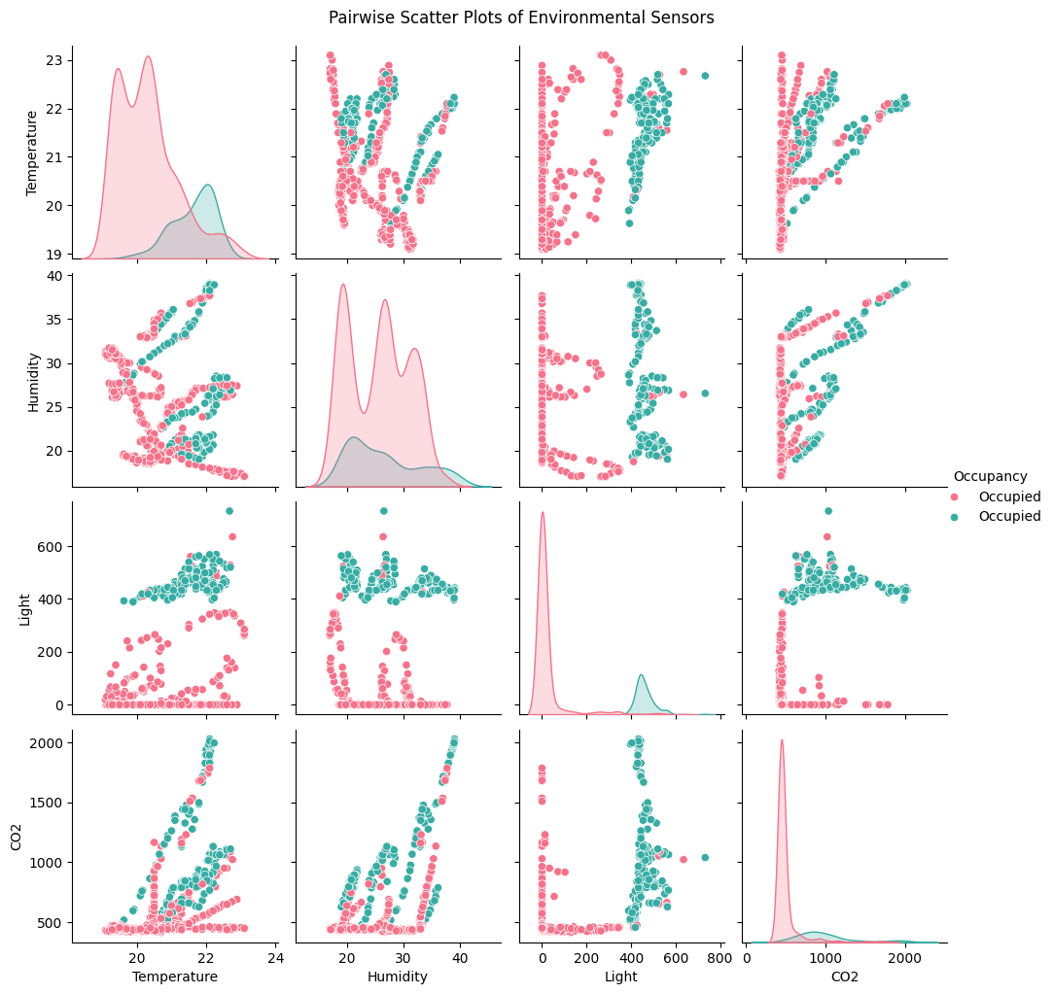

Figure 3.5: Pairwise relationships between environmental sensor features

Chapter 4: Ethical Consideration

Personal Data and Privacy
The Occupancy Detection dataset contains only environmental sensor measurements which include temperature and humidity and light intensity and CO₂ levels. The dataset does not contain any information which could identify specific individuals. The dataset includes occupancy labels which were created from time-stamped images but it does not include the actual images. The data has been anonymized according to established standards.

GDPR Considerations
The dataset does not include personal information about people because it lacks names and identifiers and demographic information. As a result the General Data Protection Regulation (GDPR) requirements do not apply to this dataset.

Ethical Approval
The project does not need institutional ethical approval because it did not collect any new human participant data. The research uses a publicly available dataset from the UCI Machine Learning Repository.

Permission and Licensing
The dataset is licensed under the Creative Commons Attribution 4.0 (CC BY 4.0) license which permits research use when proper citation is provided (Candanedo, 2016).

Chapter 5: Methodology

Overview and Tools Used
I describes the methodology used to develop and evaluate machine learning models for occupancy detection. The workflow involved processing data through feature engineering and dataset preparation before proceeding to training and optimization and evaluation and cross-validation and explainable AI testing which used Python libraries.
Tools and Libraries Used
- Python: Primary programming language used for data processing and model development.
- Pandas: Used for loading datasets, cleaning data, and performing data manipulation tasks.
- NumPy: Used for numerical operations and array based computations.
- Matplotlib: Used to produce graphs and visual representations of the data.
- Seaborn: Used for statistical visualization during exploratory data analysis.
- Scikit-learn: Used to implement machine learning algorithms and model evaluation methods.
- SHAP: Used for explainable AI analysis to interpret model predictions and understand feature influence.

Feature Engineering and Dataset Preparation
- I extracted time data from timestamps to determine which hour and which day of the week and whether the time fell on a weekend.
- I extracted Occupancy as the target variable which they wanted to predict from the set of input features.
- I deleted the initial timestamp because machine learning models require date information in a different format.
- I used StandardScaler to standardize Temperature and Humidity and Light and CO₂ because they wanted to make all features comparable for better model development.
- I splitted dataset into 80/20 for training and testing purpose

Model Selection and Technical Rationale
Occupancy Prediction was experimented on by me using techniques like Logistic Regression, Gradient Boosting Machine and K-Nearest Neighbor (KNN).
- Logistic Regression was selected because it is a simple and interpretable classification algorithm. The research uses this model as a primary baseline which performs binary classification tasks to solve occupancy detection problems.
- I selected Gradient Boosting Classifier because it functions as an ensemble technique which unites multiple decision trees to develop an effective predictive system. The model was designed to understand complex relationships that exist between environmental sensor data and occupancy status.
- I also included K-Nearest Neighbors (KNN) because it uses distance measurement to classify data points by identifying their similarity to nearby data points. The research uses this method to identify local trends found in environmental sensor data.
Table 5.1 shows the initial model configuration that I used in my research.
Table 5.1 Initial Model Configuration
Model | Key Parameters | Description
Logistic Regression | max_iter = 1000 | Linear classification model used as baseline
Gradient Boosting | default parameters | Ensemble tree model capturing complex relationships
K-Nearest Neighbors | default parameters | Distance-based classifier using nearest neighbors

Hyperparameter Optimization
The research required Grid Search Cross-Validation to determine which parameter combinations produced the best results for different algorithms. Grid search tests different parameter combinations to identify the best setup which produces the highest F1 score results.
Table 5.2 Hyperparameter Search Space
Model | Parameter | Search Values
Logistic Regression | C | 0.1, 1, 10
 | solver | lbfgs, liblinear
Gradient Boosting | n_estimators | 50, 100
 | learning_rate | 0.05, 0.1
 | max_depth | 3, 5
KNN | n_neighbors | 3, 5, 11
 | weights | uniform, distance

Model Evaluation
After model optimization, performance evaluation used several classification metrics. These metrics measure prediction quality and help compare model performance.
Accuracy
Accuracy measures the proportion of correct predictions made by the model.
$$Accuracy=\frac{TP+TN}{TP+TN+FP+FN}$$
TP represents true positives. TN represents true negatives. FP represents false positives. FN represents false negatives.
Precision
Precision measures how many rooms predicted as occupied were occupied in reality.
$$Precision=\frac{TP}{TP+FP}$$
Higher precision indicates fewer false occupancy detections.
Recall
Recall measures how many occupied rooms the model detected correctly.
$$Recall=\frac{TP}{TP+FN}$$
Higher recall indicates better detection of occupied rooms.
F1-Score
F1 score combines precision and recall into a single performance measure.
$$F1-Score=2 X \frac{Precision X Recall}{Precision+ Recall}$$
F1 score provides balanced evaluation when class distribution shows imbalance.
Evaluation also used confusion matrices. Confusion matrices display correct and incorrect predictions across classes. ROC curves with AUC scores measured the ability of models to distinguish between occupied and empty rooms. Higher AUC values indicate better classification performance.

K-Fold Cross Validation
I used 5-fold cross-validation to validate the performance of my research models. The method requires the dataset to be divided into five subsets because each subset serves as a validation set while the remaining subsets function as training data. Model performance assessment uses the average of all folds which demonstrates both model stability and generalization performance.

Sensor Dominance and Failure Analysis
I studied which environmental sensor had the greatest influence on occupancy prediction during my research. The optimized Gradient Boosting model enabled me to evaluate feature importance values which identified the most important predictor.
I removed the Light sensor feature from the model to create a simulation of sensor failure. I assessed light sensor impact on model performance by comparing model results between light sensor presence and absence using the F1 score. This analysis allowed me to measure how much the model’s performance depends on specific sensors.

Temporal Generalization Analysis
I conducted an experiment to test whether the model could make generalizations for different times of day. I divided the dataset into two parts which included daytime observations that occurred between 08:00 and 18:00 and nighttime observations.

Explainable AI (XAI)
My study required Explainable Artificial Intelligence (XAI) methods to achieve better prediction comprehension. SHAP (SHapley Additive Explanations) served as my primary tool to study how different environmental elements affected the model's prediction results.
I created a SHAP dependence plot to study how CO₂ levels affected the likelihood of room occupancy. The analysis demonstrated how CO₂ concentration levels across indoor spaces created non-linear connections to human presence.

Chapter 6: Results

Overview
The study results demonstrate that environmental sensor data enables machine learning models to accurately detect room occupancy. Multiple evaluation metrics were used because relying on a single metric may not accurately represent model performance. The system establishes its accuracy through correct prediction evaluation while precision determines actual occupied room predictions and recall measures the system's capacity to identify all occupied spaces. The F1 score balances precision and recall, while ROC-AUC evaluates how well the model distinguishes between occupied and empty rooms.

Initial Model Performance
The initial machine learning models already showed strong predictive performance in my research (Table 6.1). The Logistic Regression model achieved 0.985267 accuracy 0.942308 precision 0.991329 recall and 0.966197 F1 score. The Gradient Boosting algorithm achieved better results with 0.993247 accuracy 0.974504 precision 0.994220 recall and 0.984263 F1 score. The K-Nearest Neighbors (KNN) algorithm achieved its highest results through an initial test which showed 0.993861 accuracy 0.977273 precision 0.994220 recall and 0.985673 F1 score.
Table 6.1 Initial Model Performance
Model | Accuracy | Precision | Recall | F1 Score | Train Time (s)
Logistic Regression | 0.985267 | 0.942308 | 0.991329 | 0.966197 | 0.234808
Gradient Boosting | 0.993247 | 0.974504 | 0.994220 | 0.984263 | 1.578842
KNN | 0.993861 | 0.977273 | 0.994220 | 0.985673 | 0.016977

Optimized Model Performance
The models showed minor performance improvements after hyperparameter optimization through Grid Search (Table 6.2) testing. The Logistic Regression model achieved an accuracy of 0.987109 and an F1 score of 0.970547. The Gradient Boosting model achieved its highest performance with an accuracy of 0.995703 and an F1 score of 0.989957 and a ROC-AUC of 0.999669. KNN achieved accuracy 0.993861 and F1 score 0.985673, confirming strong predictive performance.
Table 6.2 Optimized Model Performance
Model | Accuracy | Precision | Recall | F1 Score | ROC AUC | Train Time (s) | Test Time (s)
Logistic Regression | 0.987109 | 0.942779 | 1.000000 | 0.970547 | 0.991737 | 11.394228 | 0.005880
Gradient Boosting | 0.995703 | 0.982906 | 0.997110 | 0.989957 | 0.999669 | 56.334849 | 0.007223
KNN | 0.993861 | 0.977273 | 0.994220 | 0.985673 | 0.997295 | 1.017280 | 0.013844
The best identified parameters are:
- Logistic Regression: {'C': 0.1, 'solver': 'lbfgs'}
- Gradient Boosting: {'learning_rate':0.1,'max_depth':5,'n_estimators':100}
- KNN: {'n_neighbors':5,'weights':'distance'}
The optimized models display their confusion matrices and ROC curves in Figure 6.1. The results clearly show that Gradient Boosting is the best performing model in my study, achieving the highest accuracy, precision, recall, F1 score, and ROC-AUC. The confusion matrix indicates that the model misclassified very few observations when compared to its performance across all other models. The system successfully identifies between two states of room occupancy which are occupied and empty.
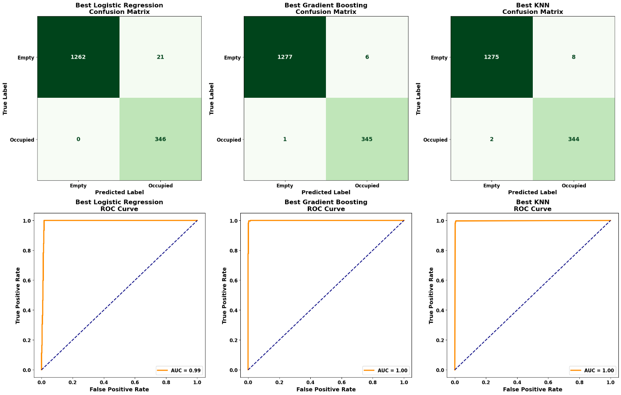
Figure 6.1: ROC Curve and Confusion Matrix

Cross Validation Results
I used 5-fold cross-validation to test whether the models produced reliable results without overfitting the training data (Table 6.3). Logistic Regression produced a mean accuracy of 0.9875 and mean F1 score of 0.9709. The best results from Gradient Boosting showed a mean accuracy of 0.9931 and a mean F1 score of 0.9839. KNN produced a mean accuracy of 0.9903 and mean F1 score of 0.9773.
Table 6.3 K-Fold Cross Validation Results
Model | Accuracy (Mean) | Accuracy (Std) | Precision (Mean) | Precision (Std) | Recall (Mean) | Recall (Std) | F1 (Mean) | F1 (Std)
Logistic Regression | 0.9875 | 0.0015 | 0.9498 | 0.0113 | 0.9932 | 0.0049 | 0.9709 | 0.0048
Gradient Boosting | 0.9931 | 0.0015 | 0.9783 | 0.0055 | 0.9896 | 0.0047 | 0.9839 | 0.0033
KNN | 0.9903 | 0.0010 | 0.9654 | 0.0048 | 0.9896 | 0.0023 | 0.9773 | 0.0030

Feature Importance Analysis (Model Success vs Failure)
Figure 6.2 shows feature importance analysis and the sensor failure experiment. The results show light intensity as the dominant predictor for room occupancy detection. The feature importance plot indicates the Light sensor holds the largest contribution to the model. Other environmental features include temperature, humidity, and CO₂ with smaller contributions.
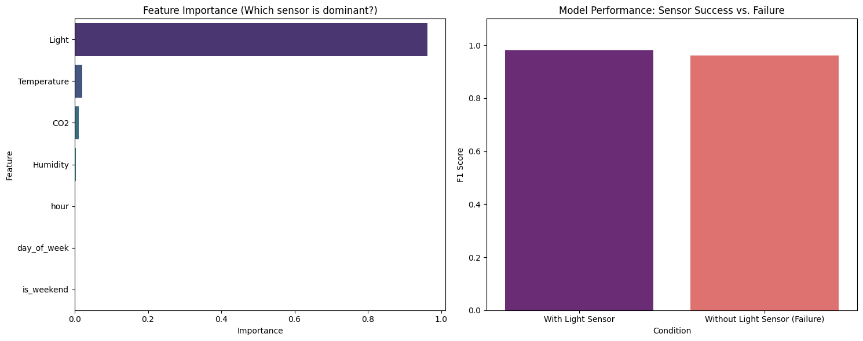
Figure 6.2: Feature Importance and Model Performance
The second part of Figure 6.2 shows model performance after removal of the Light sensor to simulate sensor failure. The F1 score drops from about 0.98 with the Light sensor to about 0.96 without the sensor. This result answers Research Question 1. Light intensity acts as the strongest predictor. The model still maintains strong performance after sensor removal.

Temporal Generalization Analysis
Figure 6.3 presents results from the temporal generalization experiment. The model achieved accuracy of 0.9931 during testing on daytime data. Daytime data matches the conditions used during model training. Testing on nighttime data produced accuracy of 0.9977.
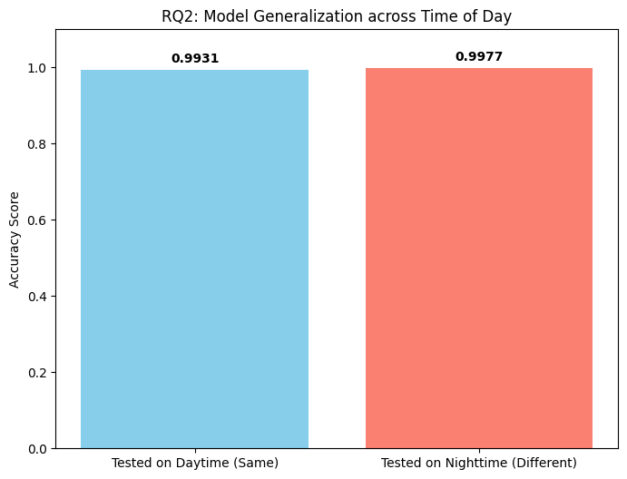
Figure 6.3: Model Generalization across Time of Day
These results show stable performance across different time periods. The model maintains prediction accuracy under both daytime and nighttime conditions. This outcome answers Research Question 2 and shows successful temporal generalization.

Explainable AI Results
Figure 6.4 presents the SHAP dependence plot for CO₂ levels. The plot shows the influence of CO₂ concentration on occupancy predictions. SHAP values increase with higher CO₂ concentration. Higher CO₂ levels increase the probability of room occupancy classification. This pattern confirms a non linear relationship between CO₂ concentration and occupancy probability. This finding answers Research Question 3.
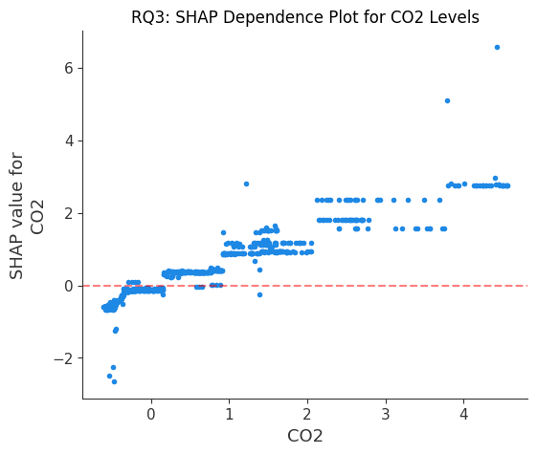
Figure 6.4: Shap dependance plot
Figure 6.5 shows the SHAP summary plot. The plot displays the contribution of each feature to model predictions. Light and CO₂ show the largest influence. Temperature and humidity show moderate influence. Temporal variables such as hour, day of week, and weekend indicator show smaller influence.
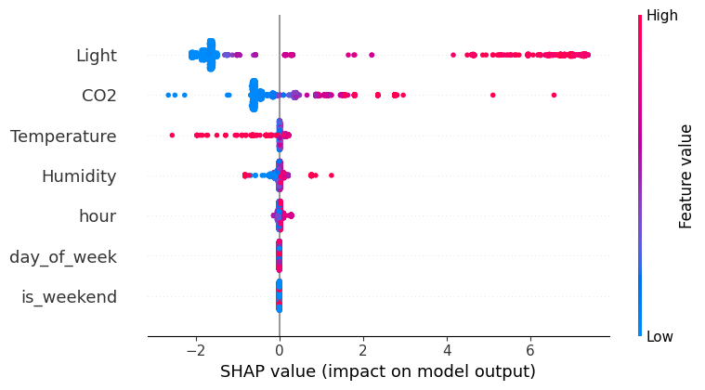
Figure 6.5: SHAP Summary Plot
These results show high predictive performance and clear interpretability. The model explains how environmental sensor measurements influence room occupancy detection.

Research Questions Addressed and Practical Applicability
The research questions get answered through the results which demonstrate that light intensity serves as the main predictor while the model maintains its functionality across sensor malfunctions and different times of day. SHAP analysis confirms the non-linear influence of CO₂ levels on occupancy prediction. The findings establish their actual application for usage in energy management systems designed for smart building operations.

Chapter 7: Analysis and Discussion

Overview of Results
This chapter analyzes the results produced by the machine learning models in this study. The discussion connects these results with the research objectives and research questions. The main goal of this research focused on development of a reliable machine learning system for room occupancy detection using environmental sensor data. Results in Chapter 6 show high predictive performance. Environmental sensors such as temperature, humidity, light intensity, and CO₂ support accurate occupancy detection in smart buildings.

Best Performing Model
The Gradient Boosting classifier produced the best performance among all evaluated models. After hyperparameter optimization, the model reached accuracy of 0.995703, precision of 0.982906, recall of 0.997110, and F1 score of 0.989957. These values show strong classification performance across occupancy states.
Gradient Boosting works as an ensemble learning method. The method combines multiple decision trees to improve prediction accuracy. Each new tree corrects errors produced by earlier trees. This step by step learning process captures complex relationships between environmental sensor measurements and occupancy patterns.
Logistic Regression works as a linear model. Linear models struggle with complex feature interactions. KNN uses distance based similarity. Distance based methods show sensitivity to noise and feature scaling.

Comparison with Previous Research
The results align with earlier research discussed in Chapter 2. Studies such as Kim et al. (2023) reported successful occupancy estimation using environmental sensors such as CO₂ concentration. Research by Zeleny et al. (2024) also reported high accuracy through machine learning based occupancy detection systems.
The results in this research show comparable or slightly higher performance than earlier studies. The model achieved accuracy above 0.995. Several factors explain this improvement, combination of multiple environmental sensors improved predictive capability. Ensemble learning through Gradient Boosting improved classification performance. Feature engineering and hyperparameter optimization also improved model learning.

Sensor Importance and Research Question Analysis
Feature importance analysis identified light intensity as the most influential variable for occupancy prediction. This result answers Research Question 1. The experiment removing the light sensor produced a small reduction in F1 score. The model still maintained strong performance using other environmental features.
The temporal generalization experiment addressed Research Question 2. The model maintained high accuracy across different times of day. The model shows strong generalization across temporal conditions instead of dependence on specific training patterns.
Explainable AI analysis addressed Research Question 3. The SHAP dependence plot showed a non linear relationship between CO₂ concentration and room occupancy. Higher CO₂ concentration increases the probability of room occupancy. Human presence changes indoor air composition. The model captures this environmental pattern.

Practical Applicability of the Model
The results show clear potential for real world smart building applications. Accurate occupancy detection supports automated control of lighting systems and HVAC systems. Automated systems reduce unnecessary energy consumption.
Lighting systems and ventilation systems shut down when rooms become empty. This behavior improves energy efficiency in buildings.
Environmental sensors operate without visual monitoring. This design avoids privacy issues linked with camera based monitoring systems. Offices, universities, and smart homes benefit from this approach.

Limitations of the Study
Several limitations appear in this research. The dataset originated from a single office environment. Occupancy patterns differ across building types such as homes or large commercial spaces.
The dataset also includes a limited number of environmental sensors. Additional sensors such as motion sensors, sound sensors, or Wi Fi signals improve occupancy detection accuracy.
Real world deployment introduces challenges. Sensor malfunction, environmental noise, or changes in building usage patterns affect system performance.

Relationship to Research Objectives
The results satisfy the objectives defined in Chapter 1. The research developed machine learning models for room occupancy prediction using environmental sensor data. Sensor failure analysis confirmed model robustness. Explainable AI analysis explained how environmental variables influence occupancy predictions.

Chapter 8: Conclusion
The study created a machine learning system which detects room occupancy through environmental sensor data. The results showed that all models performed well, with Gradient Boosting achieving the best performance, reaching accuracy 0.995703 and F1 score 0.989957. The analysis of feature importance revealed that light intensity and CO₂ concentration function as the primary factors which determine occupancy. The model demonstrated its ability to maintain effective detection performance during sensor failures and tests across multiple time periods which proved its capacity to handle actual occupancy detection requirements.
The findings show that environmental sensor-based occupancy detection can be applied in smart buildings, offices, and smart homes to automate lighting and HVAC systems, which leads to better energy efficiency and improved indoor comfort. Future work could extend this research by incorporating additional sensors such as motion, sound, or Wi-Fi signals and by testing the models in different building environments. Further studies could also explore deep learning models and real-time IoT deployment to improve scalability and predictive accuracy in practical smart building applications.

Chapter 9: References
Afolabi, A. S., Akinola, O. A., Odetoye, O. A., & Adetiba, E. (2025). Indoor Occupancy Detection Using Machine Learning and Environmental Sensors. Journal of Smart Science and Technology, 5(1), 17–39. https://doi.org/10.24191/jsst.v5i1.101
Blazevic, M., Arz Von Straussenburg, A. F., & Riehle, D. M. (2024). Sensing the Unseen - Using CO2 as a Key Indicator for Occupancy Detection in Smart Collaboration Spaces. Procedia Computer Science, 239, 1312–1319. https://doi.org/10.1016/j.procs.2024.06.301
Khan, I., Zedadra, O., Guerrieri, A., & Spezzano, G. (2024). Occupancy Prediction in IoT-Enabled Smart Buildings: Technologies, Methods, and Future Directions. In Sensors (Vol. 24, Number 11). Multidisciplinary Digital Publishing Institute (MDPI). https://doi.org/10.3390/s24113276
Kim, J., Bang, J. Il, Choi, A., Moon, H. J., & Sung, M. (2023). Estimation of Occupancy Using IoT Sensors and a Carbon Dioxide-Based Machine Learning Model with Ventilation System and Differential Pressure Data. Sensors, 23(2). https://doi.org/10.3390/s23020585
Mena-Martinez, A., Alvarado-Uribe, J., Molino-Minero-Re, E., & Ceballos, H. G. (2024). Indoor occupancy monitoring using environmental feature fusion and semi-supervised machine learning models. Journal of Building Performance Simulation, 17(6), 695–717. https://doi.org/10.1080/19401493.2024.2399053
Mohammadabadi, A., Rahnama, S., & Afshari, A. (2022). Indoor Occupancy Detection Based on Environmental Data Using CNN-XGboost Model: Experimental Validation in a Residential Building. Sustainability (Switzerland), 14(21). https://doi.org/10.3390/su142114644
Zeleny, O., Fryza, T., Bravenec, T., Azizi, S., & Nair, G. (2024). Detection of Room Occupancy in Smart Buildings. Radioengineering, 33(3), 432–441. https://doi.org/10.13164/re.2024.0432

Appendix:

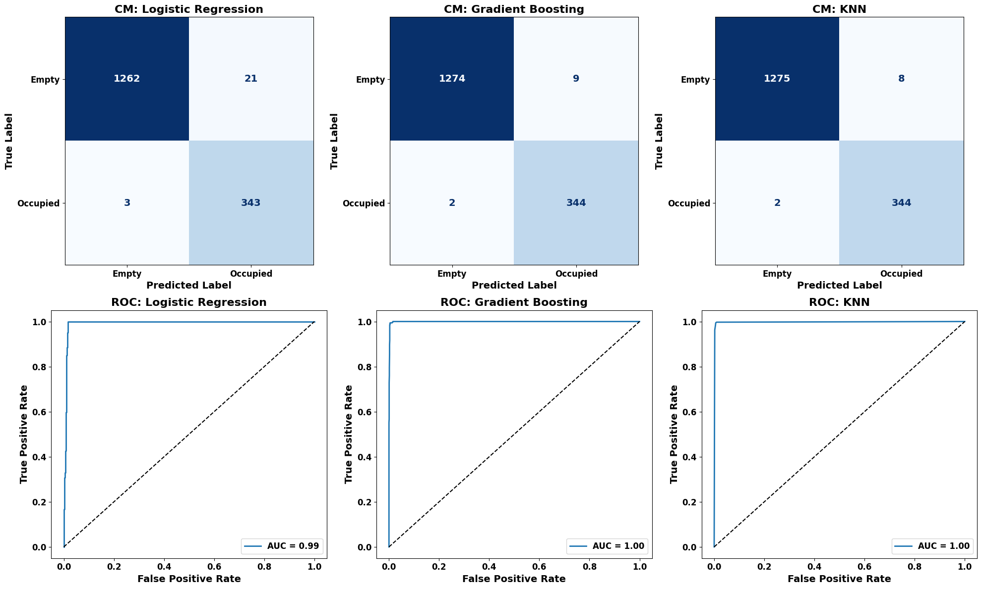

https://archive.ics.uci.edu/dataset/357/occupancy+detection

